Grade 3 Student-Facing Work

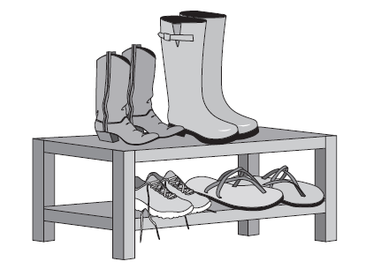
Working with Equal Groups
Introducing
Multiplication and
Division
Lesson 1
Discussion, formative assessment and practice

1. Are the groups equal or unequal? If the groups are equal, describe, in words, how the objects are arranged.

a) 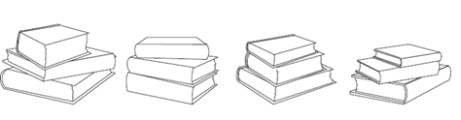

equal unequal

______________________________________________

c) 

b) 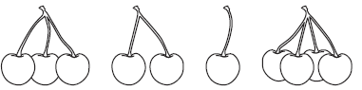

equal unequal

______________________________________________

equal unequal

______________________________________________

2. Farmer Brown sells his eggs in packs of 12. In one month, he sold 1,349 packs. Use equal groups language to describe how many eggs he sold in a month.

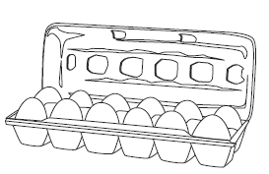

3.
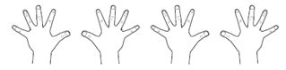

Are the groups of fingers equal or unequal?

How many groups do you see?

How many in each group?

Lesson 2
Discussion, formative assessment and practice

1. Use symbols to describe the total number of legs on the spiders. Then represent the spider legs with words.



Symbols:

Words:

2. Use the terms discussed during the lesson to properly name each number and symbol.

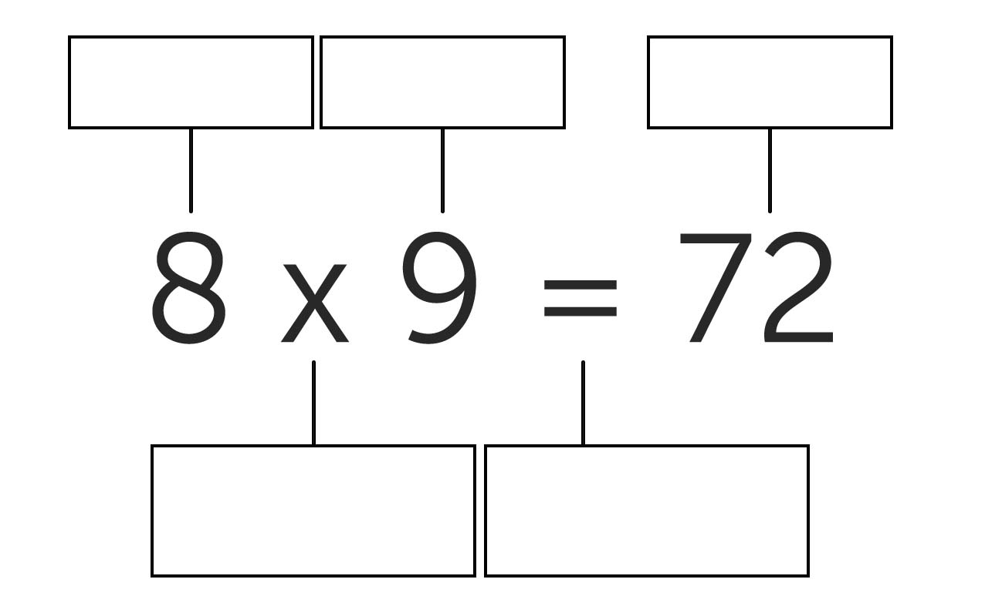

3. Use the pencils to answer the questions below.

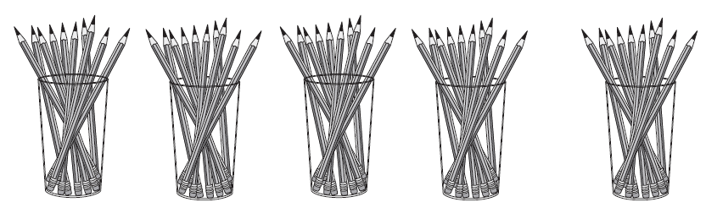

a) Write an equation to describe the arrangement of pencils.

b) What are the factors in the equation you wrote?

4. Circle the two correct ways to describe the number of dog legs.

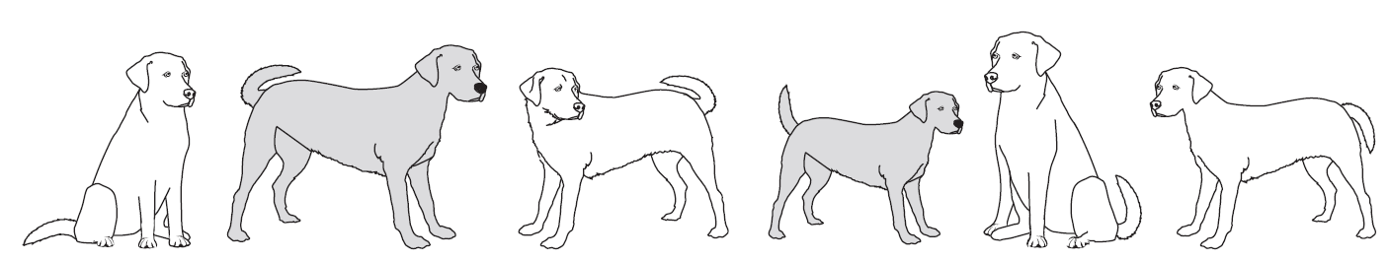

6 equal groups of 4 legs 4 × 6 24 = 6 × 4 4 groups of 6 is 24

Lesson 3
Discussion, formative assessment and practice

1. Create a visual model that represents each multiplication situation.

a) 3 equal groups of 5 flowers each.

c) The product of 9 and 5

b) 6 × 10

2. Use the images to answer the questions below.

a) Circle the two visual models that represent 6 × 3 = 18.





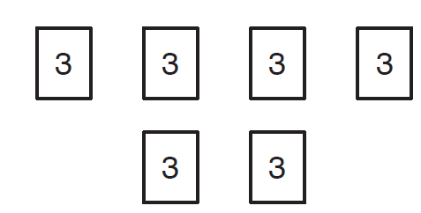


.

b) For the models that aren’t circled, explain why they do not represent the multiplication equation

3. Sally drew marks to represent groups of feathers. Describe the arrangement of feathers with words and with symbols. Include the product in your answer.



4. Describe a drawing that would show 695 × 843.

5. There are five rows of desks with six desks in each row.

a) Draw a picture to show the arrangement.

b) How many chairs are there?

c) Write a multiplication equation that represents the situation.

Lesson 4
Discussion, formative assessment and practice

1. Use the image to answer the questions below.


a) Write an equation that represents the array.

b) What is the product in the equation you wrote?

2. Mr. Jones is buying tiles to retile his floor. Write an expression with two factors to show how many tiles he will need.

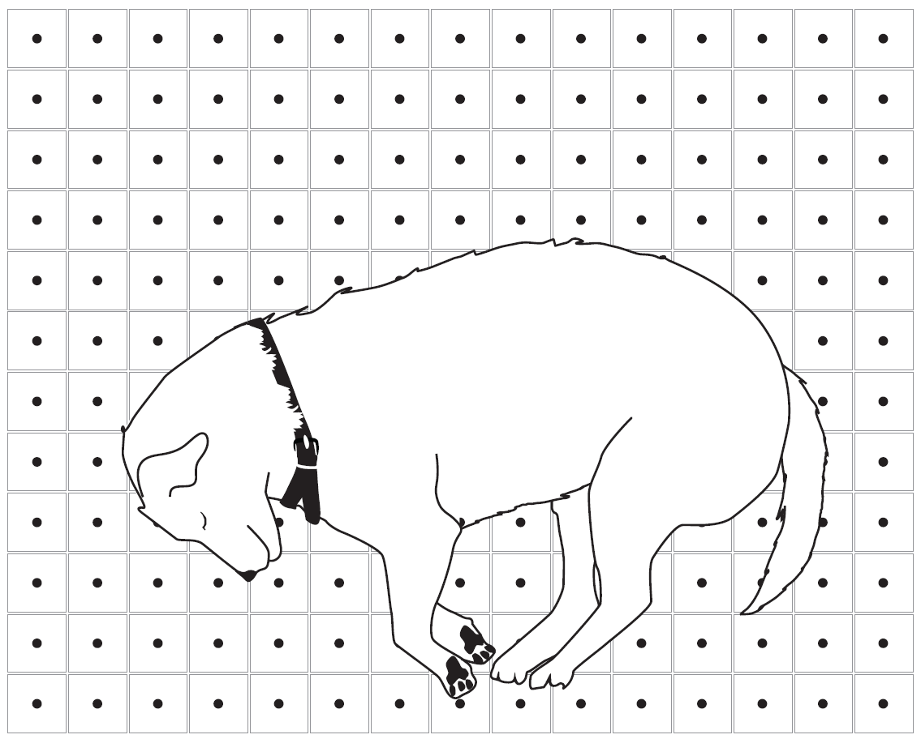

______________________________________________

3. Samantha said “these arrays both represent 6 × 3, because they both show 18 dots.”



Do you agree or disagree with Samantha? Explain your answer.

Lesson 5
Discussion, formative assessment and practice

1. Solve.

a) 5 × 1 = _______

c) _______ = 7 × 8

e) 7 × 10 = _______

b) 6 × 8 = _______

d) _______ = 3 × 4

f) 10 × 7 = _______

Circle the 4 facts that were quickest for you to answer. Why were you able to find the correct answer quickly?

Lesson 6
Discussion, formative assessment and practice

1. Sarah bought 48 candies and put the same number of candies in each of the goodie bags shown.

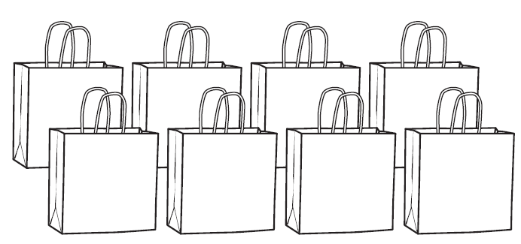

a) Write a multiplication equation to represent this problem.

b) How many candies did she put in each bag?

2. Mr. Brown is arranging the 20 desks in his classroom in an array. He puts the desks into 5 rows. Each row has the same number of desks.

a) How many desks are in each row?

b) Create a visual model of the desks.

3. A class caught 56 bugs and wanted to put them in 7 jars. Each jar will have the same number of bugs.

a) Write a multiplication equation to represent this problem.

b) They had 56 bugs, then caught 9 more bugs the next day. Write an equation to represent this problem.

.

Lesson 7
Discussion, formative assessment and practice

1. Your favorite marbles come in bags of 10. If you want to purchase 60 marbles, how many bags will you need to buy?

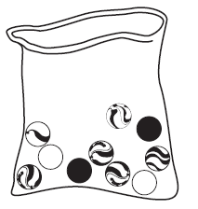

a) Write an equation to represent this problem.

b) Circle the number or symbol in your equation that tells how many bags you will need.

2. How many groups of 5 do you need to make 15? Explain how you know.

3. Solve each problem and represent it with an equation. Draw a picture, if you think it will help.

a) Maria cuts 12 feet of ribbon into 3 equal pieces so she can share it with her two sisters. How long is each piece?

b) Maria has 12 feet of ribbon and wants to wrap some gifts. Each gift needs 3 feet of ribbon. How many gifts can she wrap using the ribbon?

4. Gina and Tim are arguing about which value makes the equation _______ × 0 = 0 true.
Gina says 9 will make it true, Tim says that 1 will make it true. Who is correct Gina, Tim, both or neither? Explain your answer.

5.

a) Write a story that could be represented by the equation: 7 × 28 = c.

b) Now, draw a visual model to represent 7 × 28 = c

Lesson 8
Discussion, formative assessment and practice

1. Complete the multiplication problems below.

a) Given 4 × _______ = 12, write the related division equation

______________________________________________

c) Given 8 × _______ = 0, write the related division equation

______________________________________________

b) Given _______ × 6 = 18, write the related division equation

______________________________________________

d) Write two multiplication equations where the unknown factor is equivalent to 24 ÷ 6.

______________________________________________

2. Your favorite marbles come in bags of 10. You want to purchase 60 marbles. How many bags will you need to buy?

a) Write a multiplication equation to represent the problem.

b) Write a division equation to represent the problem.

c) Write the answer.

3. Make 3 groups of 8 stars.



Write as many equations as you can to represent the arrangement of stars.

4. Suppose there are 4 tanks and 3 fish in each tank. The total number of fish in this situation can be expressed as 4 × 3 = 12.

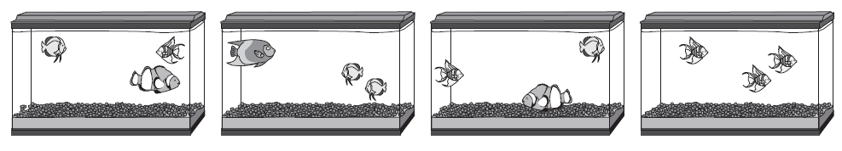

a) Describe what is meant in this situation by 12 ÷ 3 = 4

b) Describe what is meant in this situation by 12 ÷ 4 = 3

5. Complete the table.

Situation | Visual Model | Words | Symbols
 |  | the product of 3 and 15 is 45 | 3 × 15 = 45
 | 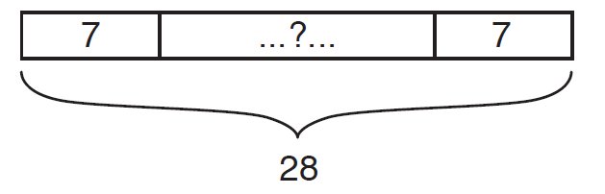
Mrs. Striker has 30 cookies to share equally with her reading class of 6 students. How many cookies will each student get?

6. Marco finds that 5 dozen eggs is equal to 60 eggs using the equation 60 = 5 × 12.

a) Write a division equation relating 5, 12, and 60.

b) What is the divisor in your equation? What does the divisor represent?

c) What is the dividend in your equation? What does the dividend represent?

d) What is the quotient in your equation? What does the quotient represent?

Lesson 9
Discussion, formative assessment and practice

1. Facts for speed and accuracy:

a) _____ × 5 = 15

c) _____ = 6 × 0

e) _____ = 7 × 10

g) 9 × 2 = _____
b) 10 $÷$1 = _____

d) _____ = 20 ÷ 5

f) 1 × 6 = _____

h) 0 × 5 = _____

2. Facts for accuracy:

a) 4 × 9 = _____

c) 27 $÷$3 = _____

e) _____ = 7 × 3

g) 0 ÷ 5 = _____
b) _____ = 3 × 3

d) _____ = 56 ÷ 7

f) 4 × 8 = _____

h) 24 = 3 × _____

Lesson 10
Discussion, formative assessment and practice

1. For each problem, write an equation and give the answer. You can draw a visual model if you think it will help.

a) Liam is baking cookies. The recipe says you need 2 cups of sugar in each batch of cookies. Liam needs to make 4 batches of cookies. How many cups of sugar will he need?

b) Liam bought 5 bunches of bananas. Each bunch has exactly 5 bananas. How many bananas does Liam have?

c) Nina bought 12 apples. She needs to use 3 apples in each batch of muffins she makes. How many batches of muffins can she make?

d) Owen is building a rectangular tile patio that is 4 tiles wide and 6 tiles long. Tiles come in packs of 12 each. How many packs of tiles does he need to buy?

2. For each picture, write a question that would require multiplication or division to answer.

a)

b)

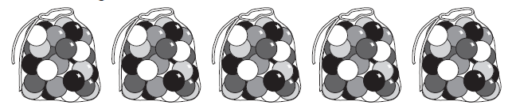

3. Tanya took a picture at a boat race. There were 5 boats competing in the race, but she took this picture of the boats that finished first, second, and third. Each boat has 9 people.

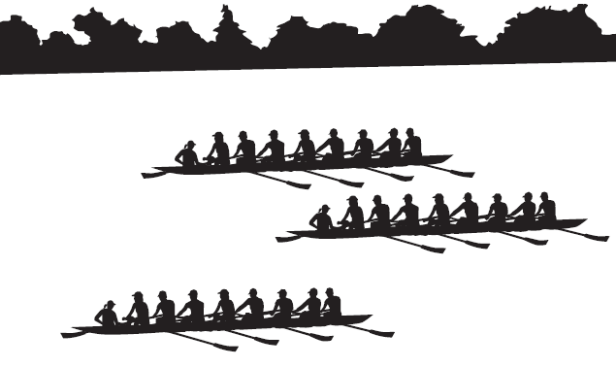

a) What is the total number of people competing in the boat race?

There are 90 people signed up for next week’s boat race. The rules say that each boat must have 9 people.

b) Write an equation that shows how to find the number of boats in the race.

Lesson 11
Discussion, formative assessment and practice

1. Find the product:

a) 9 × 2 = ___

c) ___ = 6 × 4
b) ___ = 8 × 0

d) ___ 5 × 10 =

2. Find the quotient:

a) 20 ÷ 5 = ___

c) ___ = 12 ÷ 2
b) ___ = 7 ÷ 1

d) 100 ÷ 10 = ___

3. Find the missing value in each equation:

a) ___ × 5 = 40

c) 49 = 7 × ___

e) 2 × 2 = ___
b) ___ =2 × 9

d) ___ = 8 × 1

f) 64 ÷ 8 =___

4. This lesson focused on facts using 0, 1, 2, 5, and 10. Which facts can you recall? Which facts take you more time? Why?

Multiplication and Division Assessment

Name:

Date:

Section 1: Fact Fluency

2 × 2 = ______ | 1 × 10 = ______
10 × 3 = ______ | 8 × 2 = ______
5 × 1 = ______ | 0 × 3 = ______
5 × 5 = ______ | 7 × 10 = ______
8 × 5 = ______ | 5 × 6 = ______
______= 5 × 3 | ______× 2 = 10
3 × ______= 6 | 8 × ______= 0
______× 10 = 50 | ______× 4 = 40
7 × 5 = ______ | ______× 2 = 8
2 × ______= 12 | ______× 1 = 9
______= 8 × 1 | ______× 5 = 20
1 × ______= 6 | 9 × ______= 45
______× 10 = 0 | ______× 9 = 18
7 × ______= 7 | ______× 2 = 20
2 × ______= 14 | ______= 10 × 10

Section 2: Answer all 12 questions.

1. Circle each picture that shows equal groups.
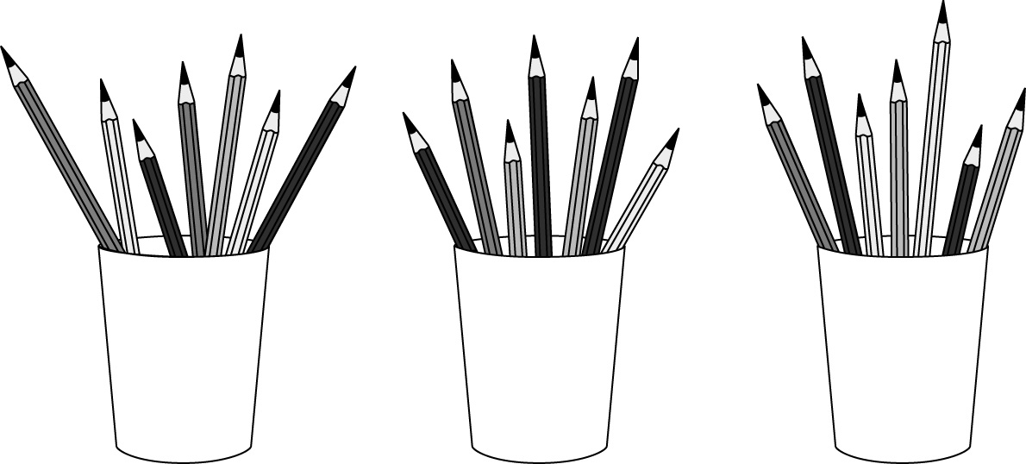 | 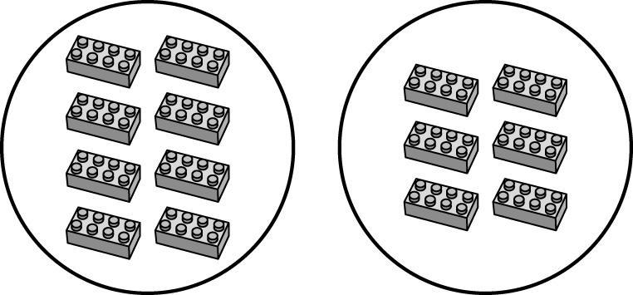 | 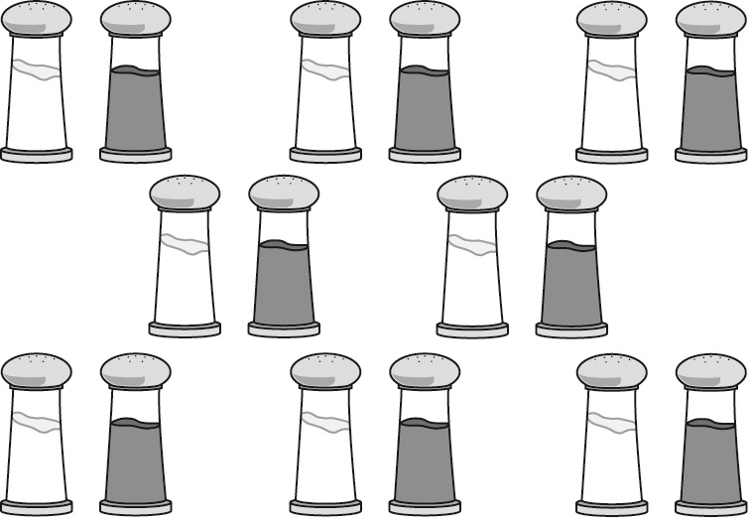 | 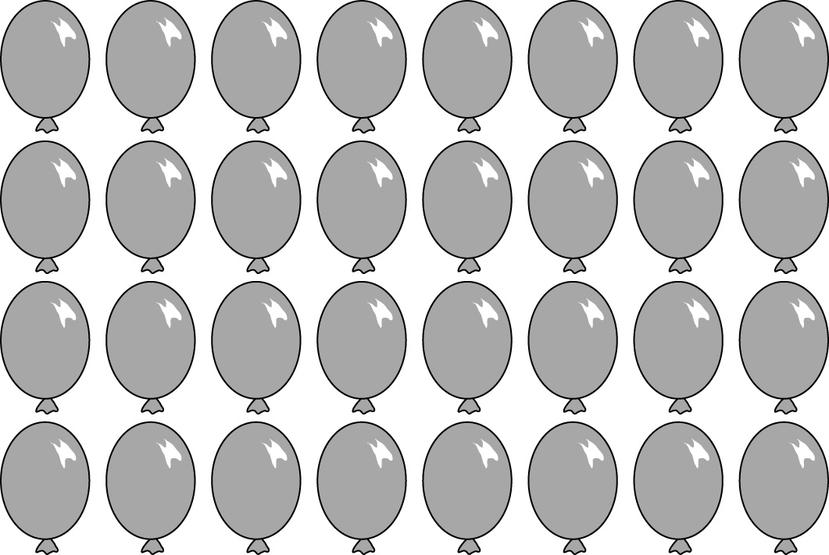

2. Packs of juice boxes are shown below.

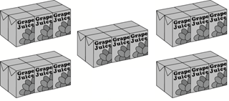

a) How many equal groups are there?

b) How many juice boxes are in each group?

c) How many juice boxes are there total?

d) Write a multiplication equation that describes the arrangement of juice boxes.

3. There are 5 bowls with 4 grapes in each bowl. How many grapes are there altogether?
_______ × _______ = _______

_______ grapes altogether
4. Rearrange the flowers in Parker’s vases so each has an equal number of flowers:

Parker’s Flowers New Flower Arrangement

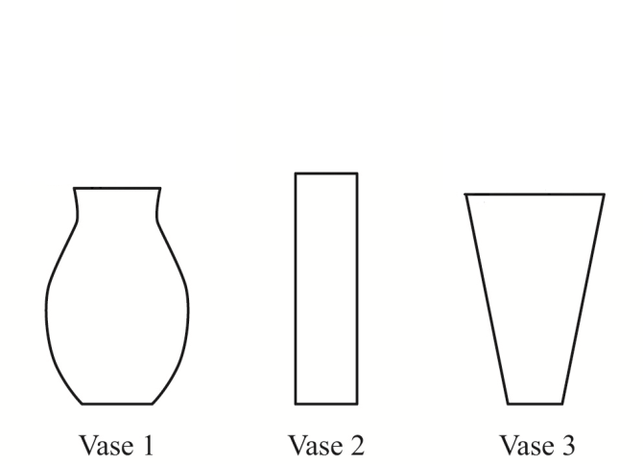
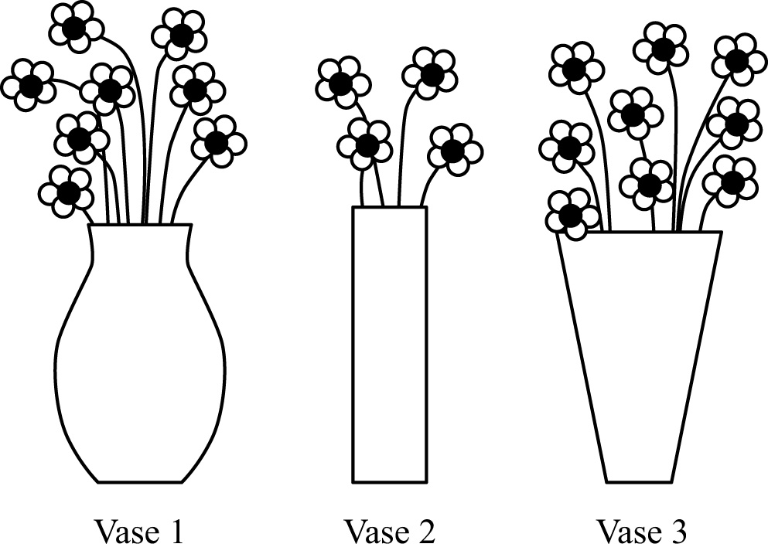

b) Write an equation to represent the new arrangement of Parker’s flowers.

5. Mrs. Oro needs 90 corn seeds. The Garden Center sells corn seeds in packs of 10 seeds each.

a) Write a division equation showing how many packs of seeds Mrs. Oro should buy.

b) Identify the quotient in your equation above by circling it.

c) Write a multiplication equation showing how many packs of seeds Mrs. Oro should buy.

d) Identify the product in your equation above by circling it.

6. What is the unknown in each of the four equations below?

a) 21 ÷ 7 = = ____________
c) 8 × □ = 56 □ = ____________
b) × 6 = 36 = ____________
d) H ÷ 3 = 4 H = ____________

7. Ken says that every time you multiply the product is greater than both factors.

Ken is wrong. To convince Ken that the product of two numbers is sometimes, but not always, greater than each of the factors:

a) Write an equation where the product is greater than both factors.

b) Write an equation where the product is less than or equal to both factors.

8. In which situation is the number of plums equal to 58 x 29?

- Sam buys 58 plums and puts 29 plums in each bag.

- Ron buys 58 bags with 29 plums in each bag.

- Tim buys 58 plums and gives 29 of the plums away.

- Dan has 58 plums and buys 29 more plums.

9. Mrs. Ling puts 30 students in teams of 5 students each.

a) Draw a diagram that shows how Mrs. Ling arranged the students:

b) Write an equation that describes the arrangement of students.

10. Mrs. Shapiro has 28 markers. She has red, blue, yellow, and black markers. She has the same number of markers in each color

a) How many markers does Mrs. Shapiro have?

b) Show your work or describe how you found your answer here:

11. Amy and Bonnie are putting an equal number of stickers into 5 sticker books. They have 100 stickers.

Amy wrote the following division equation to find the number of stickers to put in each sticker book:

100 $÷$ 5 = $_____$

Bonnie wrote the following multiplication equation to find the number of stickers to put in each sticker book:

5 × $_____$ = 100

a) Who is correct? (Circle one answer)

Neither person Amy Bonnie Both People

b) Explain your answer.

12. Describe a situation that could match the following equation: 10 ÷ 1 = 10

